

**05/11/2018)ID/102/L/B @ Dear All –**

**DUBAI** sf**]** Albwardy Damen website logo**Company:** sf**]** nflu lgDg pNn]lvt sfdbf/x?sf] dfueO{ cfPsfn] hfgrfxg] of]Uo g]kfnLgfu/Lsx?n] ;DalGwt sfdsf] cg'ejsf] k|df0f kq, ;Ssn /fxbfgL,z}lIfs of]Uotfsf] k|df0f kq, jfof]8f6f / /+uLglgnf] kbf{ ePsf] kf;kf]6{ ;fO{hsf] **)\*** k|ltxfn;fn} lvrfPsf] kmf]6f] ;lxt o; sfof{nodf t'?Gt ;Dks{ ug'{xf]nf .

**Triveni Overseas To Dubai….(9840513030)**

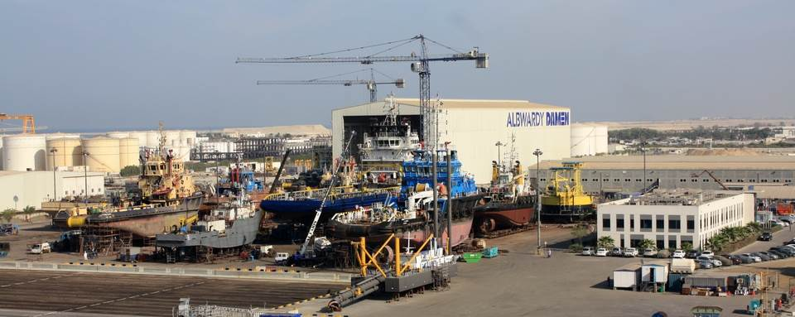

**TERMS AND CONDITIONS:-**

|  |  |  |  |  |
| --- | --- | --- | --- | --- |
| **S.N** | **CATEGORIES** | **QTY.** | **SALARY (DHS)** | **SALARY (NRS)** |
| **1.** | **ELECTRICIAN** | **15** | **1500+OT** | **46000 + OT** |
| **2.** | **PIPE FITTER** | **10** | **1500+OT** | **46000 + OT** |
| **3.** | **FINISHING CARPENTER** | **30** | **1500+OT** | **46000 + OT** |
| **4.** | **HELPER** | **20** | **1000+OT** | **31000+OT** |

**Working days 6 days 8 hrs in a week….other overtime.**

|  |  |  |  |  |  |
| --- | --- | --- | --- | --- | --- |
| **Food** | **Accommodation** | **Contract Period** | | **Duty Hours** | **Remarks** |
| **NO** | **Provided** | | **After 2 Years return ticket provided by company)** | **8 Hrs /26 days** | **000** |

Uniform,Gloves& Shoes (PPE) will be provided by company.

**selection by 'Company' representative**

**Noted:**

1**)**2 year experience in related field. Candidate’s age should be 20-37.

2)   Candidates weight minimum 50 kg and minimum HEIGHT **5.0'**

3)   After visa Receive candidate should be departure within 10 days.

4)   After 10 days if Candidate can’t departure the Company will cancel the visa without information and . Candidate Have to bear cancelation charges 2120 dhs /-.

5) **Good looking, Positive attitude, healthy, energetic & disciplined,** ARE WELCOME.,

 